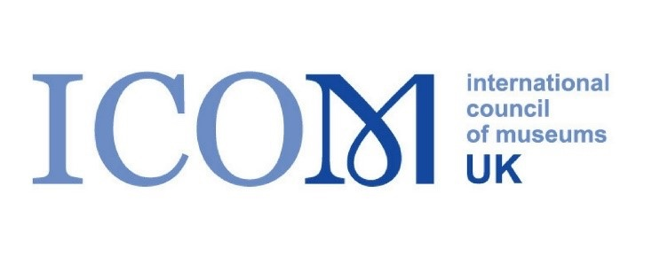
ICOM UK – Bursary scheme report
Catriona M M Rigby – ICOM-CC Triennial Conference, Oslo 2026

I would like to sincerely thank the ICOM UK Bursary Scheme Small Responsive Bursary Scheme for their generous donation towards my attendance of the ICOM-CC/Conservation Triennial Conference 2026, in Oslo, 14th-18th September 2026.
The theme of the conference was ‘Cultural Connections in Conservation’ and the posters, papers, and presentations explored the collaboration of national and international colleagues, cultures and communities to strengthen conservation ethics and practices.
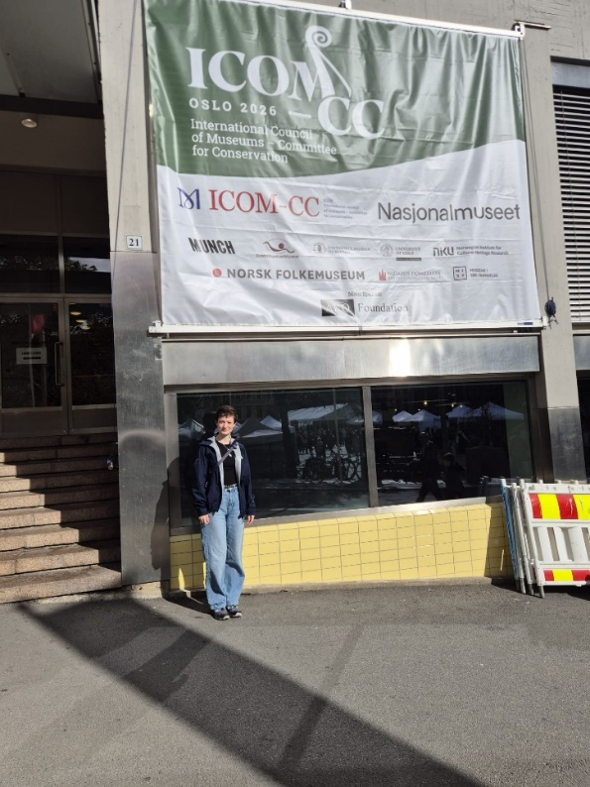
Within the budget for my internship at National Museum’s Scotland, there was an allowance to attend a conference. In order to attend this particular conference, additional funds were successfully required to cover all costs of the trip, which allowed me to attend as a spectator, allowing me to take information I learnt back to my colleagues at National Museums Scotland and others in the UK.
Image 1: Outside the Oslo Conference Centre, Catriona M M Rigby

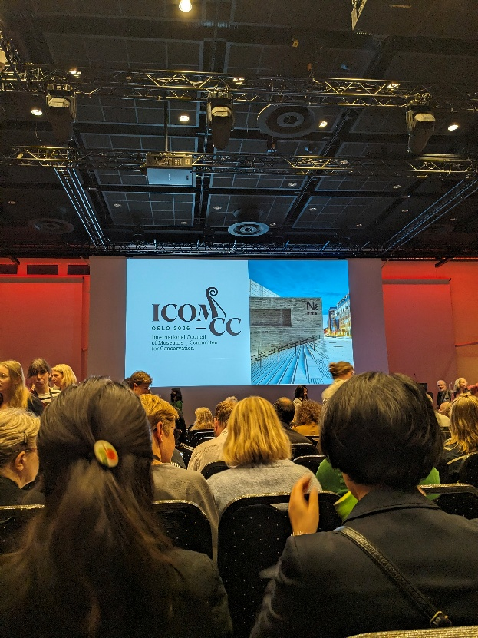
This conference was an amazing opportunity for myself as an emerging professional to begin widening my professional network on an international level. Prior to attending I had made contact over social media with a textile conservator from America with whom I spent some time at the conference, getting to know each other and our industry on opposite sides on the pond. Additionally to this contact, I was pleasantly surprised to see a previous supervisor of mine from my programme placement in Montreal, Canada, with whom I was able to catch up and through whom I expanded my Canadian network. This conference allowed for old contact to be revisited and new ones to be made and has resulted in a far better understanding of who is out there in the world in this niche field and having a much stronger group of professionals to whom I can turn to with queries and for guidance.
Image 2: Conference Welcome, Catriona M M Rigby

I listened to many interesting talks on my specialism, textiles, which can assist in my practice in future. Such as learning about laser cleaning of textiles and micro-fading as a tool to advise on preventive measures. I also attended many lectures that were not directly related to my specialism, but were very interesting to see what other specialisms are doing and possibly some approaches and treatment techniques that can be borrowed by textile conservation.
The plenary session mid week included a presentation by Miriam Clavir, who is an author whose publications have previously assisted me in the conservation of First Nations objects. Her presentation was thought provoking and enlightening. She discussed how her approach to conservation shifted over her career, resulting in a professional role very different from the one she entered into originally. She encouraged the audience to reevaluate key features often instilled in emerging professionals leaving academia, such as presuming conservators are the authority on how best to preserve cultural heritage. Though her experiences she grew to understand that original makers, users, and audiences of heritage often have experience of preservation of their own heritage and can make incredibly insightful additions to modern preservation. Through a collaboration between the two groups, preservation of the living history of cultural material can be effectively attained to ensure the cultural ties are not cut and the stories do not end after acquisition.
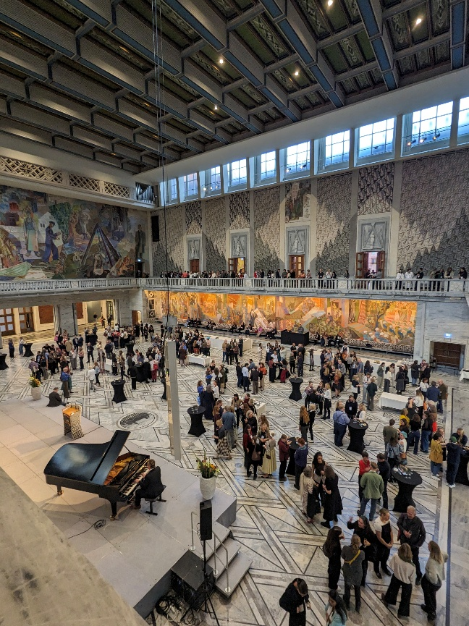
It was incredibly interesting to hear the similarities and differences in approaches to conservation from different countries and cultural backgrounds. There is a notifiable shift in the global conservation field to adopted and adapted traditional cultural practices in the care of cultural heritage. With some institutes and nations conservation practices already well combined with traditional cultural care from different communities. The hierarchy of priorities for care can clearly be seen to be having an increasing focus on the living cultural heritage and communities, drawing the emphasis away from previously prescribed conservation ideals. These shifts have proved beneficial for these institutions engagement with the communities they serve and in for the “usefulness” of objects in their care. With these new possibilities proven to be effective in other parts of the world I hope I am able to take what I have learnt from this conference and begin to introduce these ideas into my practice in the UK, ensuring a focus on cultural care in all aspects, as opposed to simply physical care of material where the museum professional is the primary authority. A vital component of this approach is to create a strong network of professionals and knowledgeable individuals from a broad range of backgrounds to create a full picture of what form this cultural care should take. This conference has additionally allowed me to begin building this network and having the tools to expand it.
Image 3: Inside Oslo City Hall, Catriona M M Rigby

I would like to reiterate my gratitude for the generous financial aid awarded by the ICOM UK Bursary Scheme Small Responsive Bursary Scheme which enabled me to attend this conference. This interesting and thought-provoking conference was even more beneficial than I had originally supposed. Ideas and procedures presented in talks and posters have prompted me to reevaluate core principles of traditional conservation and adapt to the more inclusive approaches being incorporated worldwide, which will hopefully strengthen the preservation of cultural heritage in my car and in the UK.

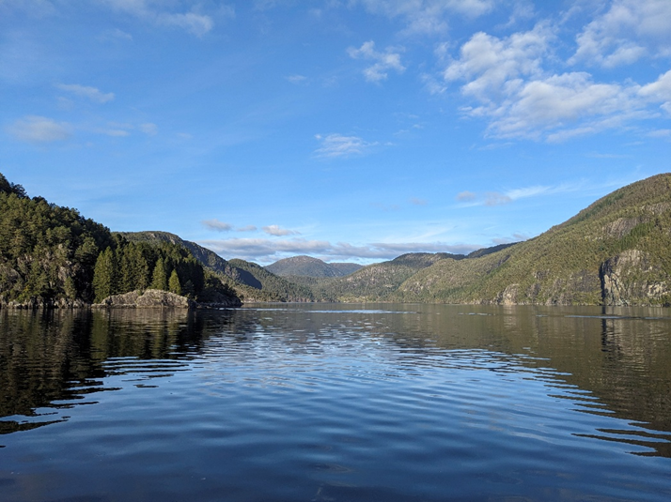
Image 4: View from a fjord, Catriona M M Rigby

