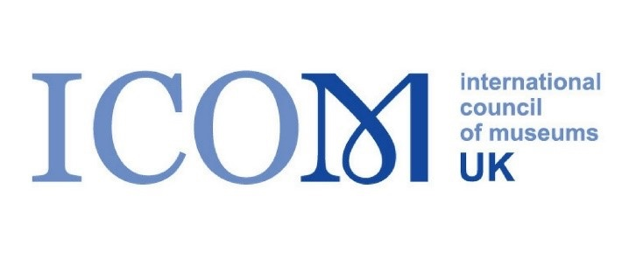
ICOM UK – Bursary scheme report

Community Spatialities, Activism, and Politics of Memory: Historicizing and Spatializing HIV/AIDS and the Struggle of Marginalized Groups
Ryan Kearney, Programme Manager, Queer Britain Museum

This symposium was organised by the University of Montreal and the Archives gaies du Québec. It was organised to coincide with the launch of a new exhibition detailing the history of ACT-UP Montreal, an activist subsidiary of ACT-UP (AIDS Coalition To Unleash Power). Speakers, including myself, where invited to present on how art and architecture have supported activist efforts in light of the ongoing epidemic. Specifically, my presentation looked at how the architecture of Britain’s gay venues shifted with the onset of AIDS in the early 1980s, as a result of negative public perceptions surrounding the spaces that gay people socialised in.

It was a great pleasure to meet other scholars based in North America, and to learn how their findings and approaches differ from those in the UK. In my capacity at Queer Britain, I also got the chance to meet museum professionals from the LGBTQ+ heritage sector in North America, including curators based at organisations in New York and Montreal.
As part of the symposium, the organisers produced a series of workshops that drew directly from materials at the Archives gaie du Québec. As a museum programmer, this gave me a good insight into how I could work more closely with Queer Britain Museum’s archives and collections to produce engaging workshops and events.
As part of the event, I will be producing a short report for my colleague Jaime Starr, the Collections Manager at Queer Britain Museum. It is my hope that we can work together on producing a handling collection that could form the core of archive participatory events.

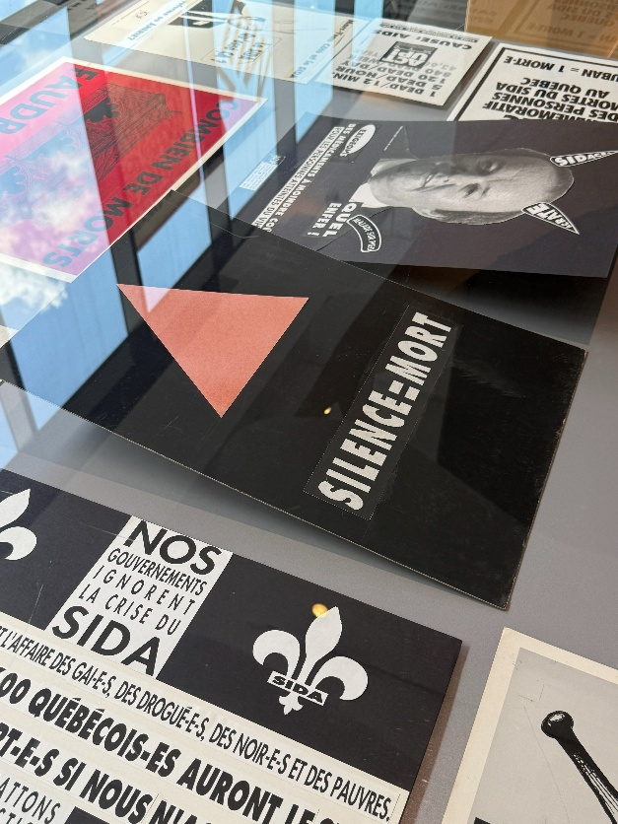
Figure 1 - Credit Line – Installation view detail of materials from the Archives gaie du Québec. Courtesy of Archives Gaie du Québec
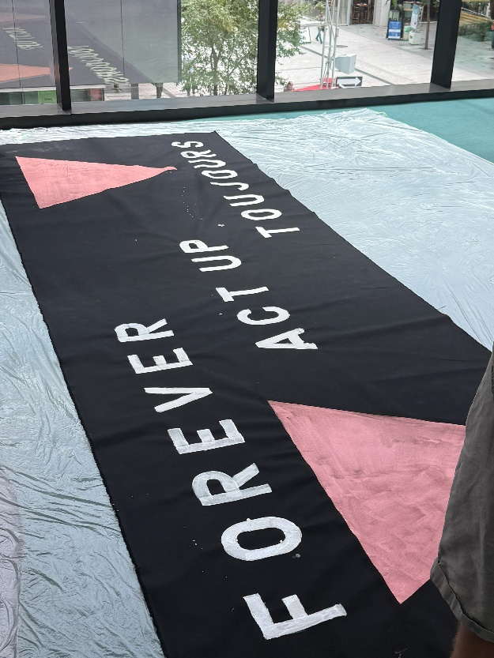
Figure 2 - Credit Line – Image from a banner making workshop as part of the symposium.

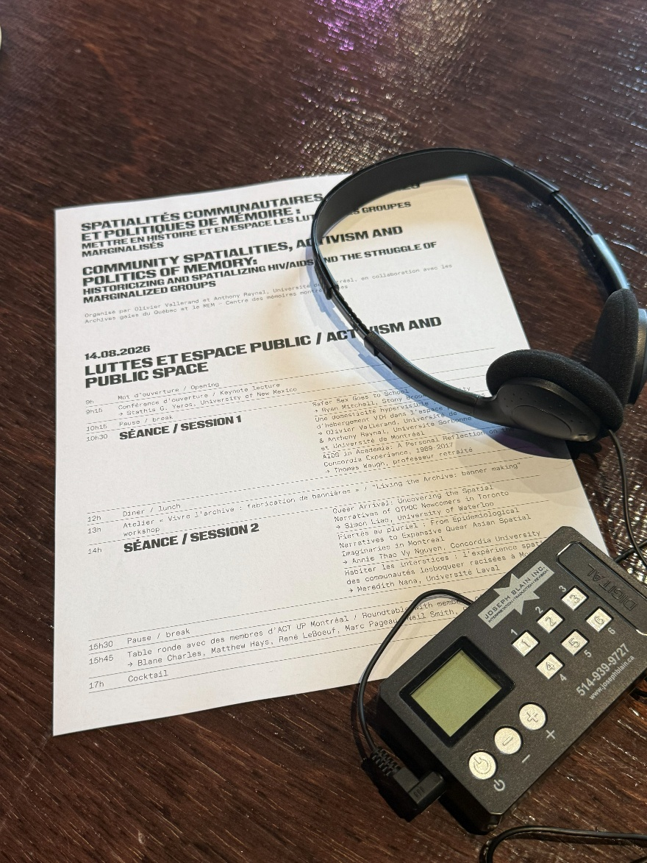
Figure 3- Credit Line – Photo of the Symposium brochure and live transaltion headpghones. Taken by Ryan Kearney

